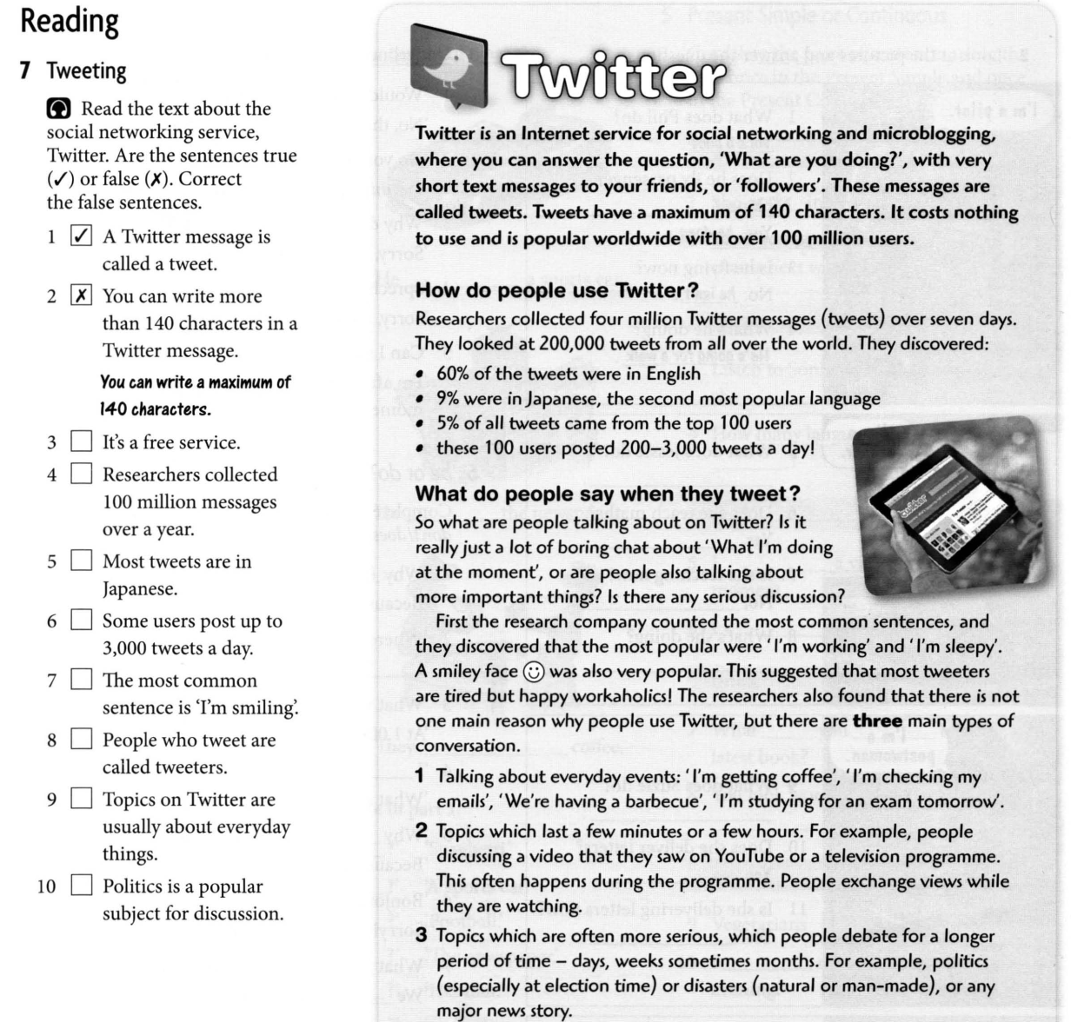

Home task
Choose any social network and be ready to speak about it.

